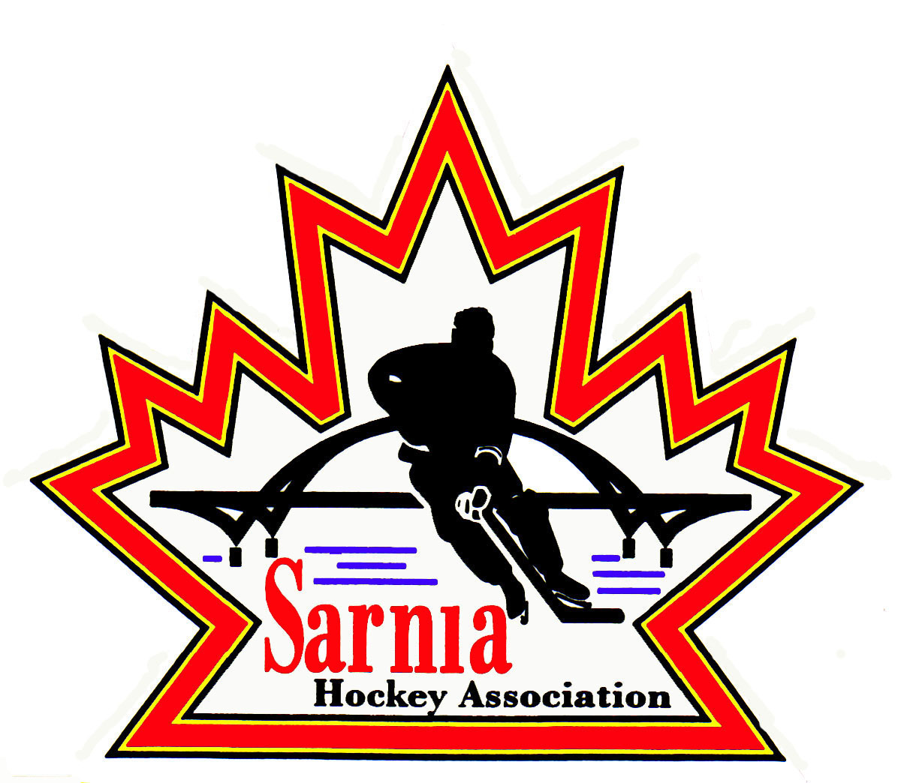

Sarnia Hockey Association

Minutes | Date: September 17, 2025 | time 7:00 pm

Meeting called by | Paul Walsh, President
Type of meeting | Regular
Secretary | Barb Walsh, Acting recording Secretary

Welcome | Paul Walsh, President, and meeting Chair welcomed everyone and called the meeting to order at 7:06 pm.

ATTENDANCE | Jerry Bernardo, Emily Brown, Terry Gray, Kyle Mellor, John Mellor, Chuck Ewart, John Ritchie, Nick Mroczek, Geoff Dale, Linda Lauzon, Jason Teather, Tim Turner, Dan Hunt, Barb Walsh, Paul Walsh  Regrets: Alister Brown, Paul Douglass, Andrew Beasley, Jacquie Beasley, David Penner, Wayne Scarrow, Ryan Gruntz, Kelly Lane, Bonny Marcy, Pat Forbes, Blake Morrison, Ted Pendle, Carrie Ritchie

ACCEPTANCE OF MINUTES | We  MOTION #250917-001  “That the Minutes from September 10, 2025, be accepted as presented.” (J. Mellor/D. Hunt)  Carried

TREASURER’S REPORT | - Report was provided by Treasurer.  - SHA Revenue still to collect. Final payments are due this Friday. Players will not be able to go on the ice if payments are outstanding. Some funds are from outside organizations.  - Rec: $20,750  - Spring A/AA: $5,925  - Spring B/BB: $4,310  - Fall Teams: $82,690  - 2.Updates  - Cousi Group Meeting last night and SHA was presented with $20,000 cheque to kick off the program. Remainder will be paid after December progress report meeting. Official cheque presentation will be done at the Sarnia Sting game on November 9th “SHA at Hive” game.  - 13 Rec players have received registration assistance to date.  - Goalie clinics to be held on PD days: 4 skill station clinics, 4 skating/edgework sessions. Ice and coaches are secured.  - Lambton Country Grant  - $25,000 has been made available to local hockey associations VI World Under 17 Hockey Challenge Legacy Fund. Each of the 10 associations will receive $2,500.00  - We need to determine how best to use these funds, then report back with metrics.  - Cheque presentation on Friday, September 19th Sting Game.  - Team Accounts – Fall Rep teams +U11 Select Accounts are being set up with Pat Forbes support.

BILLS TO BE PAID | MOTION #250917-002  “That the bills be paid as presented.” (E. Brown/I. Dunn)  Carried
  Recipient | Expense | Amount
  Darren Rogers  Planet Stitch  Sarnia Sting  City of Sarnia | MD Prep Skates  Player of the game pucks  238 Flex Passes for Spring teams  U18 A/AA tryouts  Primarily September ice and room rentals | $ 1808.00  $1518.72  $26,180.00  $1,952.64  $92,402.28

RePresentative Team Vice  president report | - MD Team Season structure finalized.  - U8 MD West only 20 games (Nov 1 full ice)  - U9T1 East/West crossover  - U9T2 West/Central crossover (16 games vs West and 4 games vs Central)  Travel reduced for MD teams  - MD Pilot  - Meeting recorded and available for others to hear.  - Player evaluations 4 times per year fed back to ALLIANCE to OHF.  - Results are to be summarized.  - On November 1, U9 moves to full ice; penalties will be called and served, but teams play 5 on 5. Penalized player returns directly to the bench after penalty has been served.  - Question was asked whether this is for entire season and answer to be provided.

B/BB Report | - All tryouts are complete, and rostering is underway.  - U8 and U9 tryouts to movement to spring is under consideration.  - U9 T2 is looking for another player and a goalie. Coach to reach out to U9 Rec League Director.  - U10 B/BB is looking for a goalie. Coach to reach out to U11 Rec League Director.  - Goalie shortage is occurring in many centers.  - Need to generate excitement/interest in goalie position (player of the game pucks etc.) and have goalie support for those interested in pursuing the position.

ICE Report | - Rep scheduling is pretty much done.  - Referees to be scheduled for these games.  - SHA Referee Director needs TV for a referee meeting (Gerry to provide key). ALLIANCE to reimburse Sept 20 room rental cost.  - Coach mentorship meeting room secured. Ice scheduler needs to know time (time is in email).  - Select team tryouts to start this weekend.  - Is an insurance certificate required for dryland training? Only if requested by facility.  - Goalie ice on Friday will continue at PASA 4-5 pm slot. Contacting P Burgess to confirm interest.  - Rec schedule to be populated this weekend.  - U11 needs additional ice for the extra teams (8 teams for 2025).  - Rec Steering Committee to work on goalie shortage next week.

REGISTRATION DIRECTOR | REGISTRATION REPORT:  - Total 1182 Registered players (Rep, Rec & Foundations)
  DIVISION | REGISTRANTS
  U8 MD | 18
  U9 MD | 33 (T1 & 2)
  U10 – U16 AA | 116
  U10 – U16 BB | 118
  U18 AA | 19
  U18 BB | 18
  Total Registered for Rep and MD | 322
  Foundations (2015-2020/21) | 149 (8 on waiting list)
  U7 | 117 (3 spots open)
  U9 | 147 (5 wait listed)
  U11 | 114 (22 spots open)
  U13 | 107 (29 spots open)
  U15 | 90 (18 spots open)
  U16/18 | 127 (13 spots open)
  U19 | 1
  TOTAL REC | 703 (85 spots open)

Recreational select team report | MOTION #250917-003  “That the U18 Select Team be allowed to book a 4th tournament.” (J. Ritchie/T. Turner)  Carried with 2 opposed  MOTION #250917-004  “That the Select Coaches communicate season plan/costs to Select Director prior to tryouts.” (G. Dale/J. Ritchie)  Carried

NEW BUSINESS | .  MOTION #250917-005  “To go In Camera.” (J. Mellor/L. Lauzon)  Carried  NEXT MEETING:  - Next meeting is Tuesday, October 7, 2025, at 7:00 pm at Clearwater Lower Hall.

adjournment | MOTION #250917-006  “That the meeting be adjourned.” ( D. Hunt/J. Ritchie)  Carried

Paul Walsh Barb Walsh
President Acting Secretary

